SAMPLE EXAM II QUESTIONS—Answers at end

ITOM 3306

Dr. Allen

*********NOTE: FOR FULL CREDIT, PLEASE SHOW ALL WORK**********

1. Consider the following linear programming problem.
MAX Z = 8 X1 + 10 X2
S.T. 2 X1 + 3X2 ≤ 24
-2 X1 + 2 X2 ≥ 10
X1 + X2 ≥ 6
X1 + X2 ≤ 10
X1, X2 ≥ 0

a). Use this graph to show each constraint and shade the feasible region.

b). Illustrate the slope of the objective function with a dashed line.

c). Circle the optimal solution point on your graph. What are the values of X1* and X2*? __________________________

d). What is the optimal value of the objective function? ________________

e). What would be the optimal solution point if the objective were

MIN Z = X₁ - X₂ ? __________________________
2. On the following page, formulate the following as a linear programming problem.

The Tasty Beverage Company makes two varieties of wine coolers, Tropical Blend and Citrus Blend. The coolers are sold in one-gallon “party size” bottles. Three ingredients are combined in different quantities to make both of the cooler varieties; the ingredients are Pineapple-Guava juice, Orange-Lime juice, and White Wine. The Tropical Blend is sold for $10.00 per gallon bottle, and the Citrus blend sells for $12.00 per gallon bottle. The ingredients are available at the following costs, and in the following amounts each day:

Ingredient | Gallons Available Daily | Cost per gallon
Pineapple-Guava Juice | 5,000 | $ 1.00
Orange-Lime Juice | 10,000 | $ 1.50
White Wine | 10,000 | $ 4.50

Product specification requirements are given in the following table:

Product | Requirements
Tropical Blend | At least 40% Pineapple-Guava Juice
Tropical Blend | At most 30% Orange-Lime Juice
Tropical Blend | Exactly 50% Wine
Citrus Blend | At most 25% Pineapple-Guava Juice
Citrus Blend | At least 35% Orange-Lime Juice
Citrus Blend | Exactly 50% Wine

Tasty Beverage would like to know how many gallons of each ingredient to use in each product in order to maximize daily profit.

(Note: You do not need to solve this problem. Just formulate it as a linear programming problem!)

Consider the following linear programming problem which has been formulated and solved (using Excel) to answer questions #3-9. The Excel spreadsheet, Answer Report, and Sensitivity Report are included on the following pages.

A client of an investment firm has $10,000 available for investment. He has instructed that his m9oney be invested in three stocks so that no more than $5000 is invested in any one stock, but at least $1000 is invested in each stock He has further instructed the firm to use its current data and invest in a manner that maximizes his expected overall gain during a one-year period.

The stocks, current price per share, and the firm’s projected stock price a year from now are summarized below.

Stock | Current Price | Projected Price 1 Year Hence
James Industries | $25 | $35
QM Inc. | $50 | $60
Delicious Candy Co. | $100 | $125

Formulation:
Let X1 = number of shares of James Industries to purchase
Let X2 = number of shares of QM Inc. to purchase, and
Let X3 = number of shares of Delicious Candy Co. to purchase

Maximize Z = $10 X1 + $10 X2 + $25 X3

Subject to:
($ available) 25 X1 + 50 X2 + 100 X3 ≤ 10,000
(Max $ James Industries) 25 X1 ≤ 5,000
(Max $ QM Inc.) 50 X2 ≤ 5,000
(Max $ Delicious Candy Co.) 100 X3 ≤ 5,000
(Min $ James Industries) 25 X1 ≥ 1,000
(Min $ QM Inc.) 50 X2 ≥ 1,000
(Min $ Delicious Candy Co.) 100 X3 ≥ 1,000
(Non-negativity) X1 ≥ 0 X2 ≥ 0 X31 ≥ 0
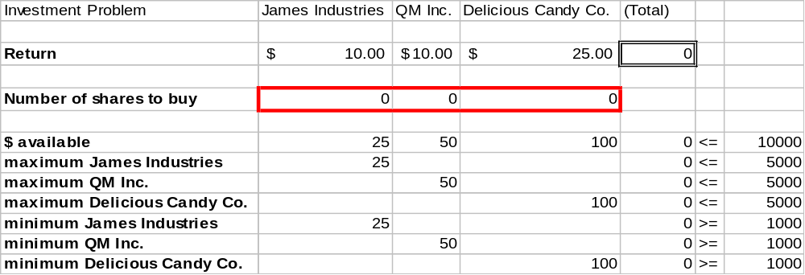
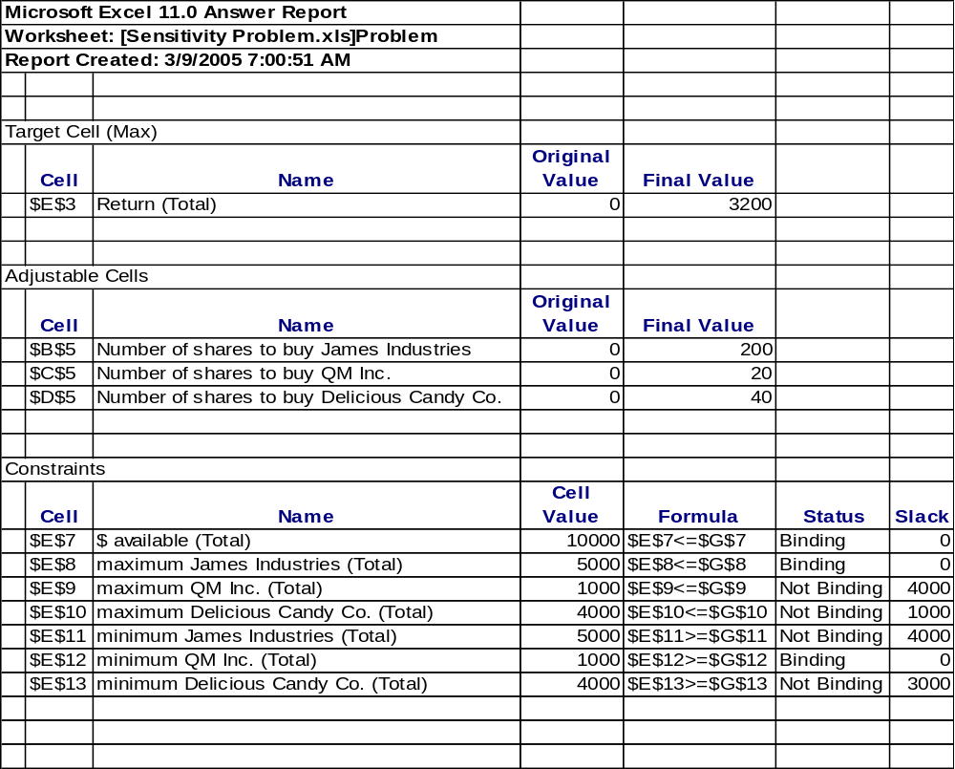
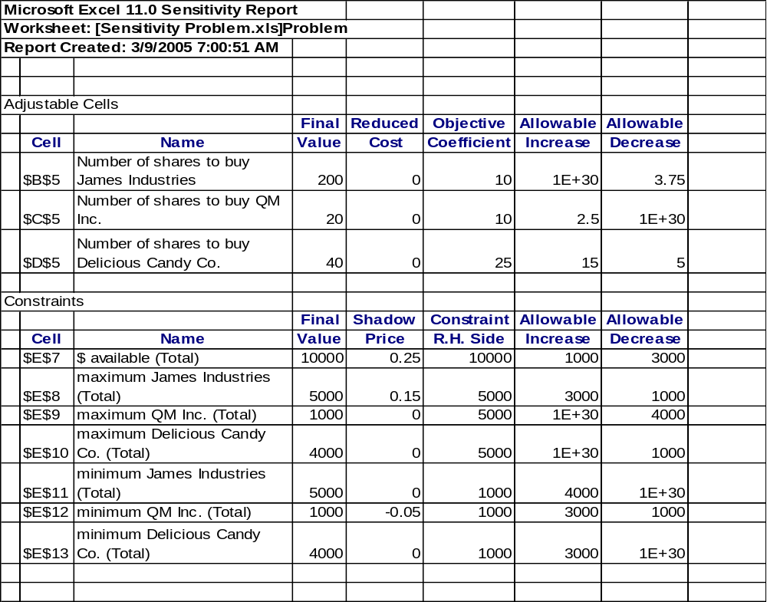
3. What is the optimal number of shares of Delicious Candy Co. to purchase?
a. 200
b. 40
c. 20
d. none of the above

4. What is the optimal expected gain?
a. $3000
b. $4000
c. $3200
d. none of the above

5. If the client had an additional $1000 to invest how much higher would the expected overall one-year gain be?

___________________________________________________

6. If the client increased the allowed maximum investment amount to $6000 for just one stock, which one should it be?

___________________________________________________

7. Based on your answer to question 6, by how much would the objective function (expected gain) increase?

___________________________________________________

8. If the expected return on shares of Delicious Candy Co. became $35 per share, would you buy more shares of Delicious Candy Co. stock? If so, how many more?

____________________________________________________

9. What value would Excel place in cell G5 of the spreadsheet if it contained the following formula? (Note that “Investment Problem” appears in cell A1)

=sumproduct(B7:B9,D7:D9)

___________________________________________________

Answers:
1. (c) X1 = 1.8 X2 = 6.8
    - Z = 82.4
    - X1 = 0 X2 = 8
2. Decision Vars:
Let PT = # gallons of Pineapple-Guava to use in Tropical Blend daily
WT = # gallons of White Wine to use in Tropical Blend daily
OT = # gallons of Orange-Lime to use in Tropical Blend daily
PC = # gallons of Pineapple-Guava to use in Citrus Blend daily
WC = # gallons of White Wine to use in Citrus Blend daily
OC = # gallons of Orange-Lime to use in Citrus Blend daily

Objective:
Max Daily Profit = Z = ($10-1) PT + ($10-1.50 ) OT + ($10-4.50 ) WT +
($12-1) PC + ($12-1.50 ) OC + ($12-4.50 ) WC

Constraints:
(limit on Pineapple-Guava) PT + PC <= 5000
(limit on Orange-Lime) OT + OC <= 10,000
(limit on White Wine) WT + WC <= 10,000
(Tropical blend at least 40% Pineapple-Guava) PT >= .4(PT+OT+WT)
(Tropical blend at most 30% Orange-Lime) OT <= .3(PT+OT+WT)
(Tropical blend exactly 50% White Wine) WT = .5(PT+OT+WT)
(Citrus blend at most 25% Pineapple-Guava) PC <= .25(PC+OC+WC)
(Citrus blend at least 35% Orange-Lime) OC >= .35(PC+OC+WC)
(Citrus blend at exactly 50% White Wine) WC = .5(PC+OC+WC)
Non-negativity PT, OT, WT, PC, OC, WC >= 0

- b
- c
- $250
- James Industries
- $150
- No
- 2500

